Geometry of CZT PET

Yifei Jin (yifeij5@illinois.edu)

1. **Overview of the Geometry**

Figure 1 Overview of the geometry of CZT PET

Figure 1 is an overview of the CZT PET system. There are generally 5 parts: PET panel1, PET panel2, PET panel3, PET panel4 and Source. Each of PET panel consists of 4 CZT detector modules. In the experiment, the source rotates around uniformly at eight directions, while the 4 PET panels remain standstill. We collect the coincidence events at each step of the source rotation and perform the interaction reconstruction with them. For a PET system with a resolution of about 650um, an exact definition of the system geometry is required before reconstruction. Any mismatch of the position or orientation of the detectors might result in the degradation of the final positioning precision. What we do here is trying to describe the geometry of the detectors and source. We begin this with the setup of the global coordinates.

1. **The global coordinates (X-Y-Z)**

The global coordinates we chose here are right-handed. As in Figure 1, the global coordinates are XYZ. The X-Y plane is located in the middle of the four detectors, with the Z axis being the rotation axis of source. X axis points from PET panel3 to PET panel4, while Y axis points form PET panel1 to PET panel2. The origin of the global coordinates is at the crossing point of XY plane and the rotation axis of source.

1. **The local coordinates of PET panels (X1-Y1-Z1, X2-Y2-Z2, X3-Y3-Z3, X4-Y4-Z4)**

All the local coordinates of 4 PET panels are right-handed. Z axis of these local coordinates point to the origin of the global coordinate and X direction of these local coordinates are the same of Z direction of the global coordinate. This is illustrated in Figure 1. The origins of these 4 local coordinates are located at the center of cathode plane.

1. **The local coordinates of CZT detector modules**

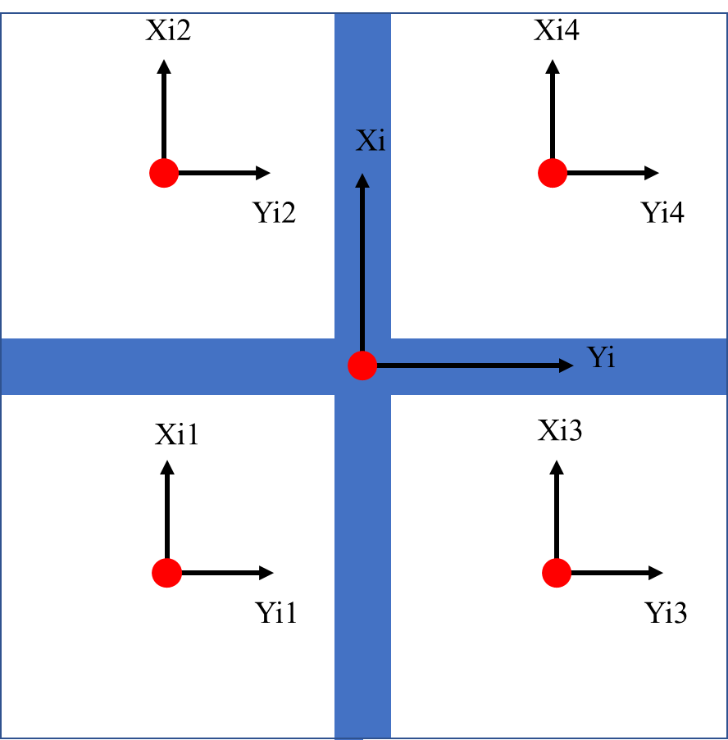(Xi1-Yi1-Zi1, Xi2-Yi2-Zi2, Xi3-Yi3-Zi3, Xi4-Yi4-Zi4)

Figure 2 local coordinates of CZT detector modules in PET panel i

As shown in Figure 2, this is PET panel i (i = 1, 2, 3, 4) and it has 4 CZT detector modules. All the local coordinates of CZT detector modules are right-handed. The origin is located at the center of the cathode of each CZT detector module. The Xij, Yij, Zij (j=1, 2, 3, 4) directions of these local coordinates are the same as Xi, Yi, Zi direction (the local coordinates of PET panels).

The detector is virtually divided into twenty layers, with layer 1 first and layer 20 last along +z axis. The origin at the center of cathode plane. (as shown in Fig.3).

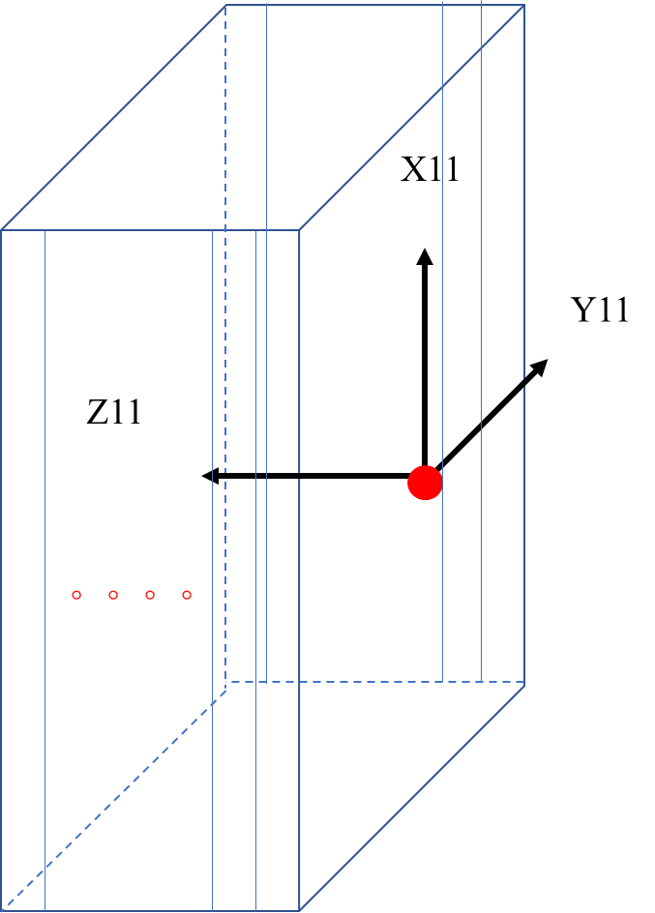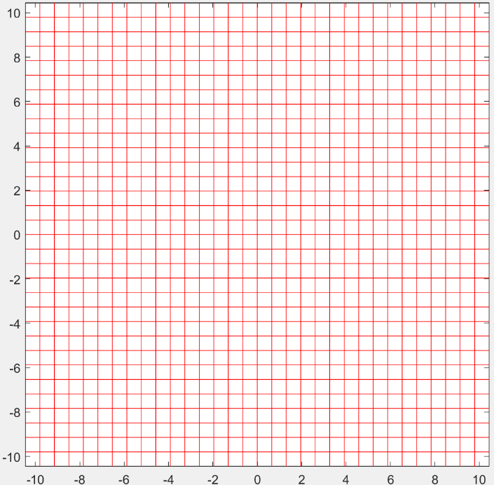

Xij

Yij

Voxel 1024

Voxel 993

Voxel 32

Voxel 1

Layer 20

Layer 1

Voxel 33

Figure 3 local coordinates of Module#11 (left), and configuration of voxel on the x-y plane (right)

There are 1024 voxels for the x-y plane of each layer. Fig.3 illustrates the configuration of the voxels on each layer. The 1024 voxels are arranged in a sequence from Voxel 1 to Voxel 1024. Please note, the dimension of each pixel in x-y plane is 650 μm × 650 μm, and the x-y coordinates of each pixel denotes the position of its center.

1. **Geometry Parameters**

There are 123 parameters (*Para*) to describe the geometry in Figure 1, as summarized in Table 1.

Table 1 Parameters for the geometry

|  |  |
| --- | --- |
| *Para*[1-3] | Source positions in XYZ |
| *Para*[4-6] | The origin of local coordinates of PET panel1 in XYZ |
| *Para*[7-9] | Euler angles of PET panel1 in XYZ, sequence is (Z->Y->X) |
| *Para*[10-12] | The origin of local coordinates of Module#11 in local coordinates X1Y1Z1 |
| *Para*[13-15] | The origin of local coordinates of Module#12 in local coordinates X1Y1Z1 |
| *Para*[16-18] | The origin of local coordinates of Module#13 in local coordinates X1Y1Z1 |
| *Para*[19-21] | The origin of local coordinates of Module#14 in local coordinates X1Y1Z1 |
| *Para*[22-24] | Euler angles of Module#11 in X1Y1Z1, sequence is (Z1->Y1->X1, β-α-φ) |
| *Para*[25-27] | Euler angles of Module#12 in X1Y1Z1, sequence is (Z1->Y1->X1, β-α-φ) |
| *Para*[28-30] | Euler angles of Module#13 in X1Y1Z1, sequence is (Z1->Y1->X1, β-α-φ) |
| *Para*[31-33] | Euler angles of Module#14 in X1Y1Z1, sequence is (Z1->Y1->X1, β-α-φ) |
| *Para*[34-36] | The origin of local coordinates of PET panel2 in XYZ |
| *Para*[37-39] | Euler angles of PET panel2 in XYZ, sequence is (Z->Y->X) |
| *Para*[40-42] | The origin of local coordinates of Module#21 in local coordinates X2Y2Z2 |
| *Para*[43-45] | The origin of local coordinates of Module#22 in local coordinates X2Y2Z2 |
| *Para*[46-48] | The origin of local coordinates of Module#23 in local coordinates X2Y2Z2 |
| *Para*[49-51] | The origin of local coordinates of Module#24 in local coordinates X2Y2Z2 |
| *Para*[52-54] | Euler angles of Module#21 in X2Y2Z2, sequence is (Z2->Y2->X2, β-α-φ) |
| *Para*[55-57] | Euler angles of Module#22 in X2Y2Z2, sequence is (Z2->Y2->X2, β-α-φ) |
| *Para*[58-60] | Euler angles of Module#23 in X2Y2Z2, sequence is (Z2->Y2->X2, β-α-φ) |
| *Para*[61-63] | Euler angles of Module#24 in X2Y2Z2, sequence is (Z2->Y2->X2, β-α-φ) |
| *Para*[64-66] | The origin of local coordinates of PET panel3 in XYZ |
| *Para*[67-69] | Euler angles of PET panel3 in XYZ, sequence is (Z->Y->X) |
| *Para*[70-72] | The origin of local coordinates of Module#31 in local coordinates X1Y1Z1 |
| *Para*[73-75] | The origin of local coordinates of Module#32 in local coordinates X1Y1Z1 |
| *Para*[76-78] | The origin of local coordinates of Module#33 in local coordinates X1Y1Z1 |
| *Para*[79-81] | The origin of local coordinates of Module#34 in local coordinates X1Y1Z1 |
| *Para*[82-84] | Euler angles of Module#31 in X3Y3Z3, sequence is (Z3->Y3->X3, β-α-φ) |
| *Para*[85-87] | Euler angles of Module#32 in X3Y3Z3, sequence is (Z3->Y3->X3, β-α-φ) |
| *Para*[88-90] | Euler angles of Module#33 in X3Y3Z3, sequence is (Z3->Y3->X3, β-α-φ) |
| *Para*[91-93] | Euler angles of Module#34 in X3Y3Z3, sequence is (Z3->Y3->X3, β-α-φ) |
| *Para*[94-96] | The origin of local coordinates of PET panel4 in XYZ |
| *Para*[97-99] | Euler angles of PET panel4 in XYZ, sequence is (Z->Y->X) |
| *Para*[100-102] | The origin of local coordinates of Module#41 in local coordinates X1Y1Z1 |
| *Para*[103-105] | The origin of local coordinates of Module#42 in local coordinates X1Y1Z1 |
| *Para*[106-108] | The origin of local coordinates of Module#43 in local coordinates X1Y1Z1 |
| *Para*[109-111] | The origin of local coordinates of Module#44 in local coordinates X1Y1Z1 |
| *Para*[112-114] | Euler angles of Module#41 in X4Y4Z4, sequence is (Z4->Y4->X4, β-α-φ) |
| *Para*[115-117] | Euler angles of Module#42 in X4Y4Z4, sequence is (Z4->Y4->X4, β-α-φ) |
| *Para*[118-120] | Euler angles of Module#43 in X4Y4Z4, sequence is (Z4->Y4->X4, β-α-φ) |
| *Para*[121-123] | Euler angles of Module#44 in X4Y4Z4, sequence is (Z4->Y4->X4, β-α-φ) |

*Para*[1-3] is the center of source. The source is viewed as a series of small pixels within a sphere. This will be covered in more details in the next section (section 5).

*Para*[4-6], *Para*[34-36], *Para*[64-66] and *Para*[94-96] are the origins of local coordinates X1-Y1-Z1, X2-Y2-Z2, X3-Y3-Z3 and X4-Y4-Z4 in global coordinate respectively.

*Para*[7-9], *Para*[37-39], *Para*[67-69] and *Para*[97-99] are the Euler angles of the local coordinates of PET panel 1-4 in global coordinates respectively. It is worth noting that the Euler angles vary on the sequences of rotation. In our configuration, the definition of Euler angles (β-α-φ) is shown in Figure 4 (it is generally in “321” sequence, in which e.g., “3” denotes rotation around z axis).

1) Z axis rotation, (β) 2) Y’ axis rotation, (α) 3) X’’ axis rotation, (φ)



X

φ

y

z

Y’’

Z’’

x(X’’)

X

Y

Z

Y’(Y’’)

α

Z’’

X’’

Z

Y

β

Y’

X’

Z(Z’)

Y

Figure 4 Definition of Euler angels

To describe the tiny movement of CZT detector modules relative to PET panels, *Para*[10-21], *Para*[40-51], *Para*[70-81] and *Para*[100-111] are the origins of 4 groups of 4 CZT detector modules in corresponding local coordinates of PET panels. Similarly, to describe the tiny rotation of CZT detector modules relative to PET panels, *Para*[22-33], *Para*[52-63], *Para*[82-93] and *Para*[112-123] are the Euler angles of the local coordinates of 4 groups of 4 CZT detector modules in corresponding local coordinates of PET panels.

1. **Coordinates of the source**

The source is seen to be composed of a series of pixels within a sphere. The center of this sphere is *Para*[1-3], and it is not the center of any pixels. Figure 5 shows the distribution of the source pixels on X-Y plan. Each pixel is a cube (100μm side length).

Center: *Para*[1-3]

Figure 5 Pixels of the source on the X-Y plane

1. **Data Format**

To adapt to different applications, such as calibration and reconstruction, we should convert original data to several different data format D1, D2 and D3.

7.1 D1: *N NG ND X Y Z VI E*

|  |  |
| --- | --- |
| *N* | Number of coincidence event (starts from 1) |
| *NG* | Number of gamma ray (starts from 1 in each event) |
| *ND* | Number of CZT detector module |
| *X* | X position of the interaction |
| *Y* | Y position of the interaction |
| *Z* | Z position of the interaction |
| *VI* | Voxel index of the interaction |
| *E* | Deposited energy of the interaction |

D1 keeps all the original information. Each interaction is described by 8 parameters as shown in Table 2. The binary file will be written interaction by interaction, in other words, 8 parameters by 8 parameters.

*N* represents the number of coincidence event which consists of at least 2 gamma rays and will start from 1, then 2 and so on. For the gamma ray in one coincidence event will have the same *N.*

*NG* is the number of gamma ray in one coincidence event and will start from 1, then 2 and so on in each event. If several interactions in one coincidence events happen on the same detector, in other word, have the same *ND,* they will be considered to come from the same gamma ray, so they will have the same *NG.* Interactions that have the same *NG* will be written adjacently and the relative order of these interactions will keep the same as the original data file.

*ND* is the number of CZT detector modules where the interaction happens. *ND* is an integer from 1 to 16. If the interaction is on Module#ij (i = 1,2,3,4 is the number of PET panel; j = 1,2,3,4 is the number of CZT detector modules in each PET panel), *ND $=4×\left(i-1\right)+j$.*

*X, Y, Z* are the 3-dimensional position of the interaction in the local coordinates of CZT detector module *ND* where the interaction happens*.*

*VI* is the voxel index of the interaction in CZT detector module *ND.* As illustrated in section 4, it will start from 1 to 1024 in the first layer, from 1025 to 2048 in the second layer and so on. *VI* can be calculated by *X, Y, Z.*

*E* is the energy that the interaction deposits in the detector.

7.2 D2: *N ND X Y Z VI*

D2 is applicated to geometry calibration. Parameter definitions are the same as D1. D2 contains the coincidence events which only have two 511keV gamma rays and each gamma ray only interacts once. Therefore, *NG* is always 1, 2, 1, 2… and *E* is always 511keV in D2, so we delete these two parameters.

7.3 D3: *N NG ND X Y Z VI E*

D3 is applicated to reconstruction. Parameter definitions are the same as D1. D3 contains the coincidence events which have two 511keV gamma rays and each gamma ray can interact multiple times.

If Compton scattering happens for one gamma ray, we will get multiple interactions in one gamma ray, but the original data won’t tell us which interaction is the first, so as D1, because D1 keeps the relative order of interactions in one gamma ray. To generate D3, we need to tune the order of these interactions by evaluating the positions and energy of these interactions. If the gamma ray has 3 or more interactions, we only keep the first two.